**Experiment 5**

**Automation and Optimization with Amazon S3**

Name : **Vaibhav Jain** Reg No : **RA2011028010103**

**Aim** : Automate Files backup to aws S3 bucket on Linux machine.

Procedure :

Steps:

1. Create a S3 bucket.
2. Create a EC2 instance.
3. Give EC2 instance Role to access S3.

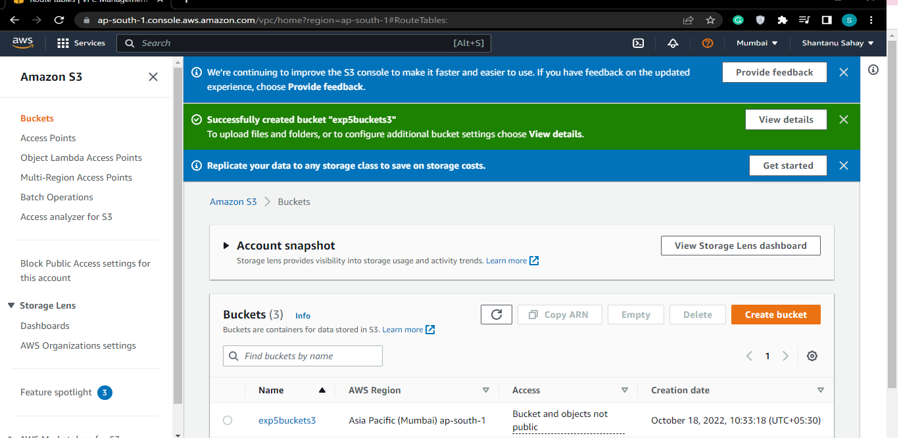

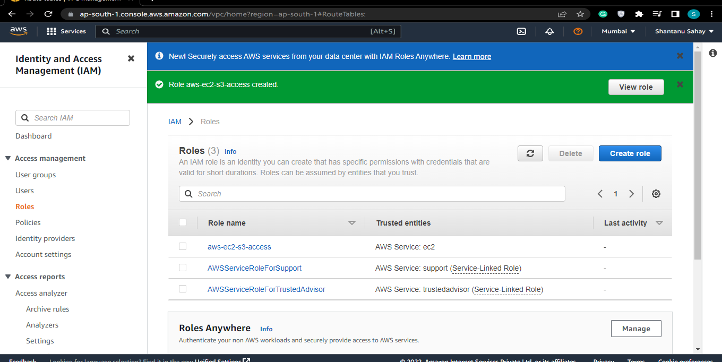

(or you may also grant access to your local linux machine using aws configure cmd and entering your IAM user credentials over there)

1. Connect to your EC2 instance CLI.
2. Type “sudo su” to give access root directory.
3. Create a directory “backup”. Type: mkdir backup
4. Go inside the “backup” directory.
5. Make some test files. Type : touch a

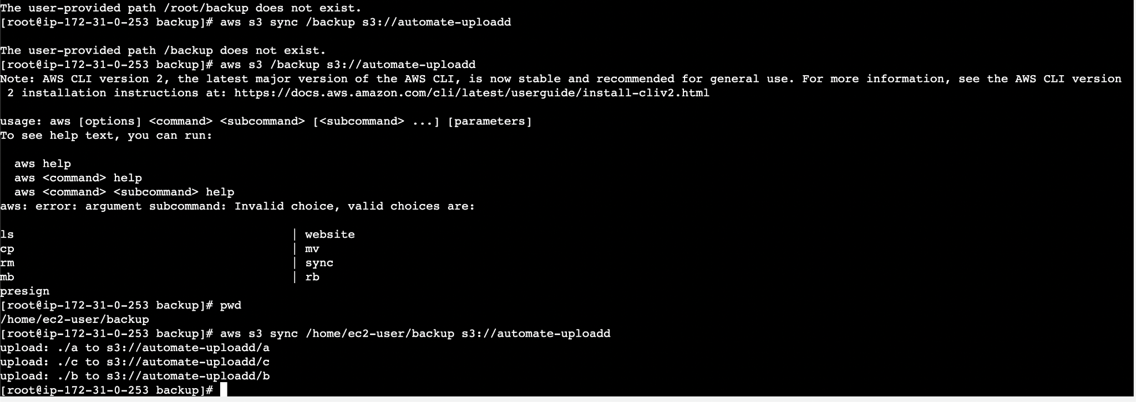

1. List Them By Cmd–ls

Now to sync these files of backup directory on the S3 bucket. Cmd : aws s3 sync localfilepath s3://bucketname

11.Now, we are going to create a cron job in order to automate this process. Cmd : crontab -e

Enter the cmd : cron code aws s3 sync /directory s3://bucketname For e.g. : cron code for 1 min is * * * * *

(you may use crontab.guru to create your own job expression) URL : https://crontab.guru/

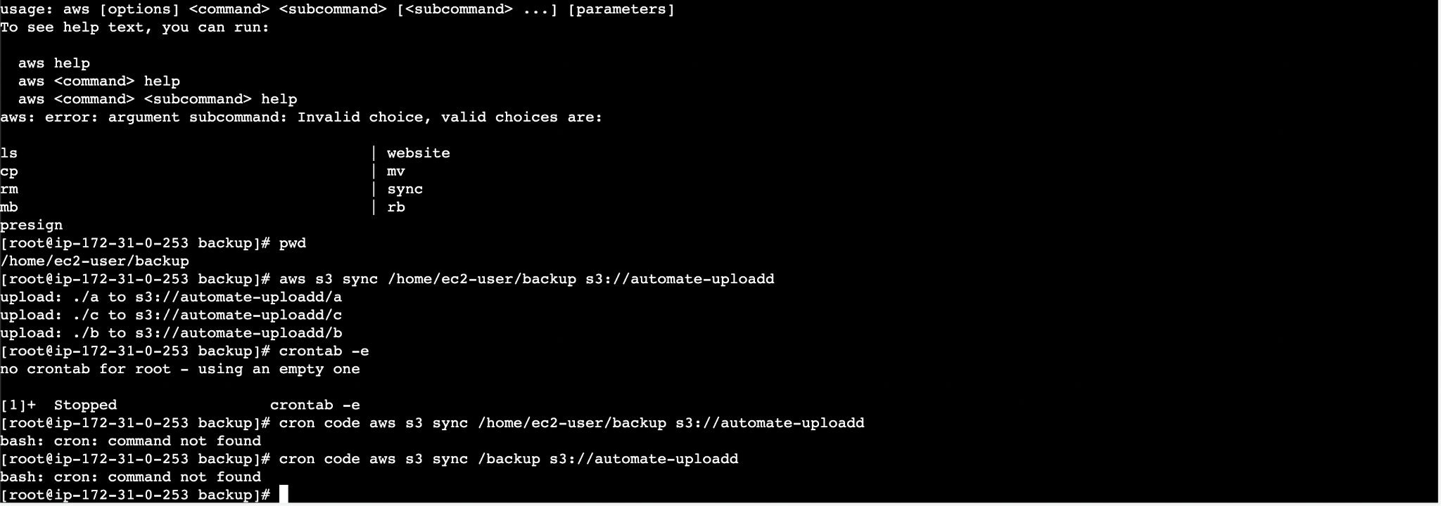

Restart the Crond service

Run “systemctl restart/stop/start cornd.service” to restart/stop/start your cron jobs respectively.

1. Now, we are going to create some test files to check if they are uploaded every minute or not.
2. File d and file e have been updated.

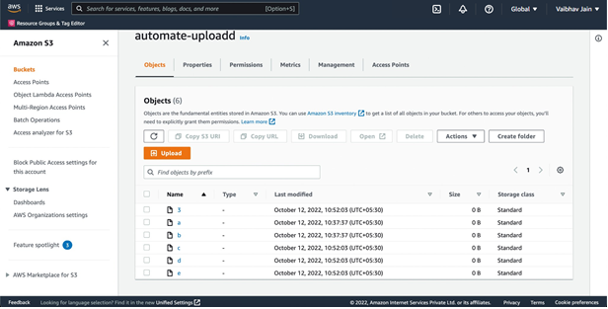

**Result:** We have successfully automated our local files/directory backup on Amazon S3 buckets using crontab.